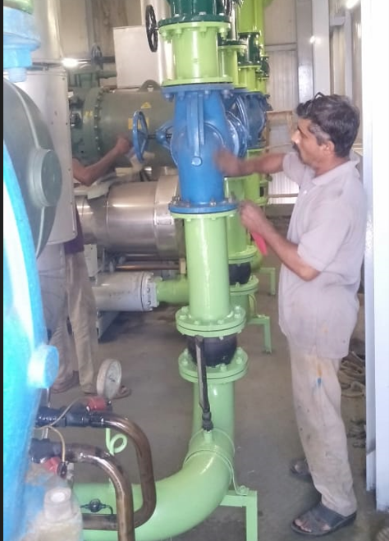

**CHILLERS / CONDENSER WORK IN PROGRESS**